Current Role(s):
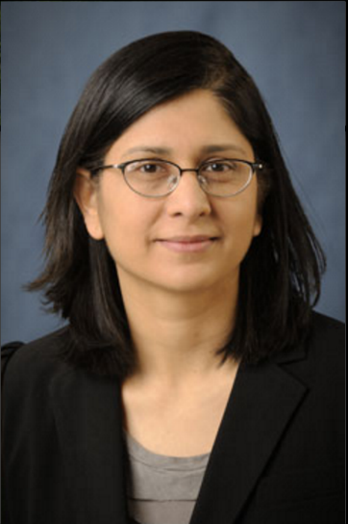
Professor of Electrical and Computer Engineering, NCSU
Center Director of ASSIST

Educational background:
BS, North Carolina State University, 1991
MS, North Carolina State University, 1992
PhD, North Carolina State University, 1995

E-mail: vmisra@ncsu.edu
Phone: (919) 515-7356

Interests: Metal oxide sensors, power devices, III-As and III-N based devices, atomic Layer deposition, nanoparticles for memory and energy storage, high-K and metal gates, organic photovoltaics and solar fuels. etc etc etc

Expertise: Insert BIOGRAPHY blurb usually used for conference brochures right here

ASSIST Project Titles:
Project 1

Project 2

Project 3

Services Offered: Sponsored Research, collaborative projects, characterization techniques, fabrication, testing and evaluation services, etc…. consulting in…

Publication Examples: [Insert publications here but only enough to fill two total pages]
[n]

[…]

[3]

[2]

[1]

[[PUBLICATIONS CONTINUE - NO MORE THAN THIS PAGE]], only 2 pages will be included in the booklet.

