**Engineering Design Process: Perfect Posture**

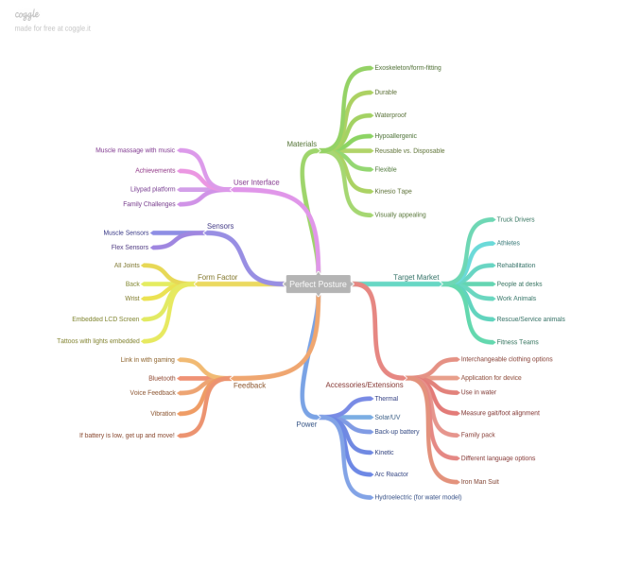**Brian Fullenkamp, Enloe High School; Tyreisha Jeffery, Northern High School; Caleb Zander, Wakefield High School; April Johnson, Wake STEM Early College High School**

**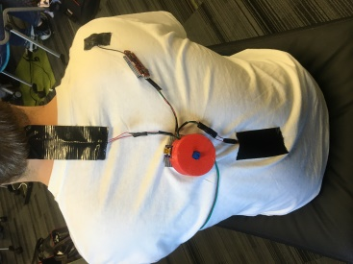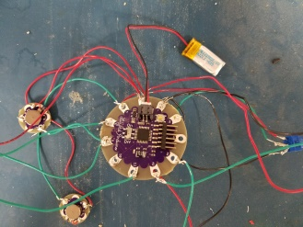****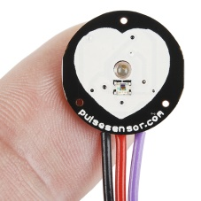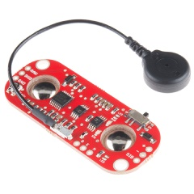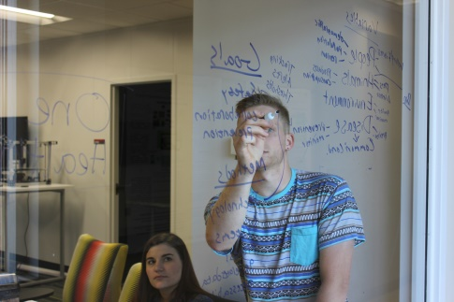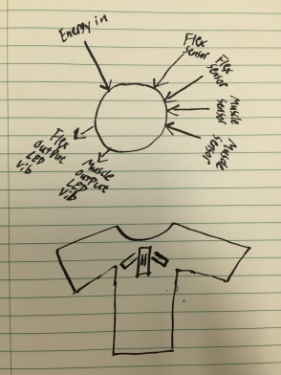**

Our first prototype

Our second prototype

Initial sketch of prototype

Muscle Tension Sensor Sparkfun.com

Pulse Sensor Sparkfun.com

Mind map of our ideation

Team brainstorming session

In our final design, the two Flex sensors are positioned in a compression shirt along the spine of the wearer while the microprocessor is housed in a 3D-printed container on the center of the shirt. The sensors as well as the microprocessor container are placed in pockets on the shirt so that the wearer can customize it to their needs. The LED was sewn into a cuff that the wearer wears on their wrist.

For future iterations of this design, we would like to incorporate an app that can track the wearer’s posture throughout the day as well as track posture goals set by the wearer. We would also like to make the overall design less bulky and much easier to change out between various pieces of clothing. Future versions would also allow the wearer to add sensors depending on the data they would like to collect, such as pulse, hydration, muscle tension, etc.

Our original device incorporated two main sensors: a Flex sensor and a Muscle sensor. If the Flex sensor was bent to a certain degree, an LED would light up red and a signal would be sent to the vibration output, alerting the wearer to adjust their posture. As the process progressed, we decided to take out the muscle sensor as it was interfering with the Flex sensors.

**Engineering Design Process**

Our team decided to make a wearable device using the Lilypad that would measure posture and muscle tension. The device would be housed on the back of a shirt and would alert the wearer when their posture is out of alignment.

Our challenge was to design a wearable device using either the Lilypad or Arduino Uno that can be used on both humans and animals.